**World Quant University**

**Professor: Ritabrata Bhattacharyya**

**Python II**

Nikolas Lippmann Pareschi - [nikolaslippmann@gmail.com](mailto:nikolaslippmann@gmail.com)

**Project 1: Calculating Best Fit Line on Any Stock Ticker**

Difficulties are explained at the end of the file.

1. Write a python program that prompts the user to enter any valid stock symbol available in Google Finance, Yahoo Finance, Quandl, CityFALCON, or another similar source for NYSE & NASDAQ. Ensure proper error handling for wrong user inputs.

To download the data I have used pandas_datareader as recommended by some colleagues in Piazza.



I have forced the user to enter correctly the Symbol with the while loop below. The symbol must be contained in the dataframe df2 (NYSE) or in the dataframe df22 (Nasdaq).

I used the try and except to deal with possible unknown errors.

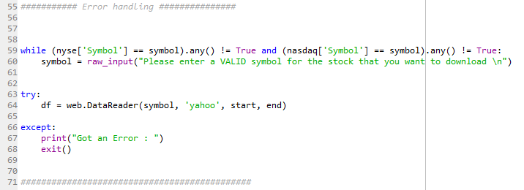

The dataframes were defined before:

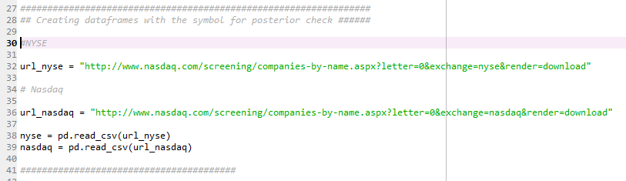

1. Download data for last 1 month for user entered ticker from Google Finance, Yahoo Finance, Quandl, CityFALCON, or another similar source.

This was done with:

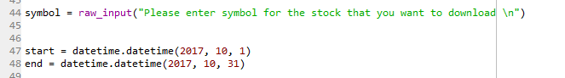

And:



1. Using Interpolation techniques, fit a quadratic line through the data points and plot the same

That was a result for fitting a quadratic line through the data points:



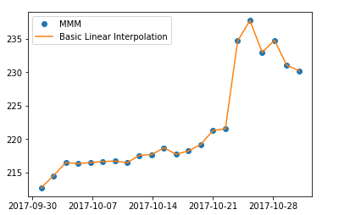

This was the code for that, It was based in our class videos.

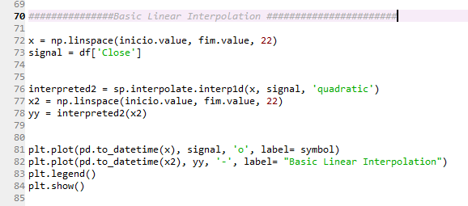

1. Choose a quadratic equation of your choice and using SciPy leastsq() optimization method calculate the best fit line with respect to the downloaded data 5. Plot the best fit line and the actual data points together with error bars.

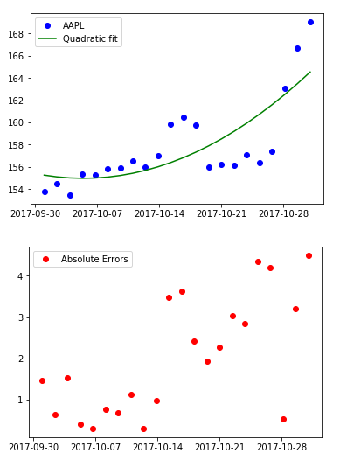

And this is the code that generated the graphs. It was based in our class and in this stack overflow post:

<https://stackoverflow.com/questions/19791581/how-to-use-leastsq-function-from-scipy-optimize-in-python-to-fit-both-a-straight>

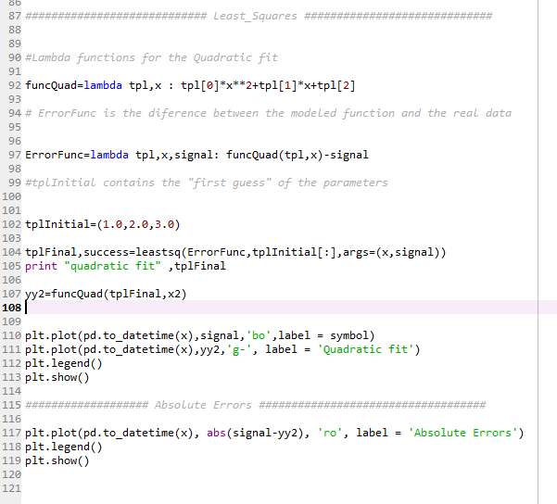

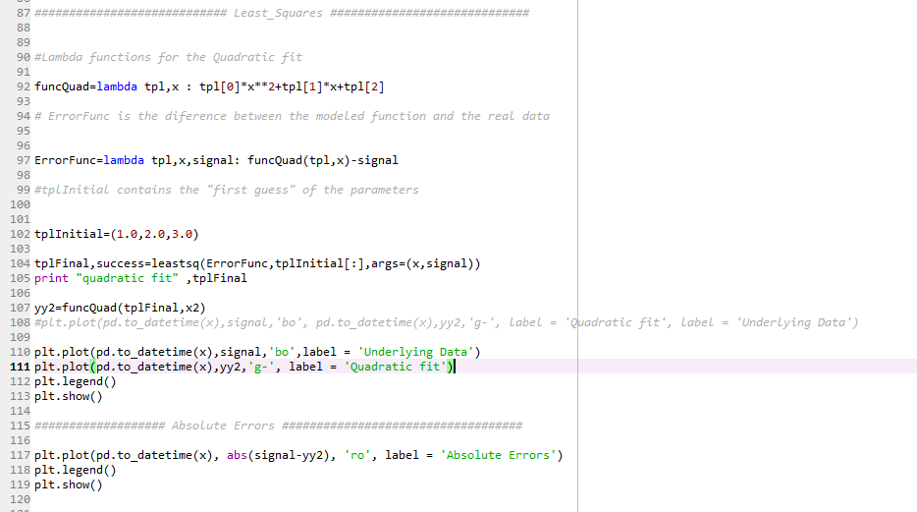

DIFFICULTIES:

1. For some odd reason the dates in the graph were not displaying in my notebook. I started the Mini I in my job PC and it was working just perfectly. I just thought I did something wrong and then I spent like 6 hours trying to fix. Then I decided to change to Python 3 in the notebook and the graphs were just fine! So I tried to reinstall the libraries and Python/Anaconda stopped working. So after reinstalling everything the dates started to appear again (always the same code).
2. I found very difficult to do the least square regression with a quadratic function. It took me several hours to accomplish that and honestly, I just hope it is right.
3. Python is crashing a lot, both at home and at the PC in my job. I believe it is because I have 2 versions of Python installed in the machine, 3.4 and 2.7.